About Manchester Metropolitan University
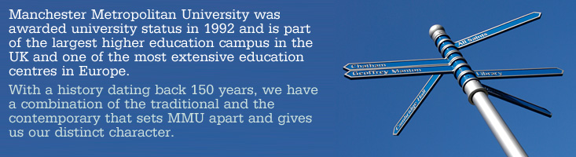
Manchester Metropolitan University was awarded university status in 1992 and is part of the largest higher education campus in the UK and one of the most extensive education centres in Europe. With a history dating back 150 years, we have a combination of the traditional and the contemporary that sets MMU apart and gives us our distinct character.
The central campus is situated close to Manchester's city centre. There are six further campus locations, four in other parts of the city and two in Cheshire, 36 miles (58 km) from Manchester:
- Faculty of Business & Law
- Faculty of Education
- Faculty of Health, Psychology & Social Care
- Faculty of Humanities, Languages & Social Science
- Faculty of Science & Engineering
- Hollings Faculty
Manchester School of ArtAlthough the University has a 150 year history, we are committed to the future. To ensure our place as a world-class university, a £250 million investment programme is underway to strengthen the student experience, with emphasis on high quality, cutting edge teaching facilities and course provision.
MMU is one of the largest providers of science, engineering and technology education in the country. In addition, the University is an international leader in clothing design and technology, home to the UK’s second largest business school, and a UK leader in art and design, law, sports science, and the health and social work professions.
We offer over 1000 courses and qualifications, including undergraduate and postgraduate degrees, research for Masters and PhDs, professional courses, BTEC HNDs and foundation degrees.
Our courses are professionally relevant, which means that MMU students graduate ready for the workplace. By providing excellent facilities and dedicated professional staff, we aim to produce graduates who will become world-class professionals. MMU’s alumni include many leaders in the professions and business.
MMU is working closely with universities around the world.
MMU working closely with the Economic Department of PSU.

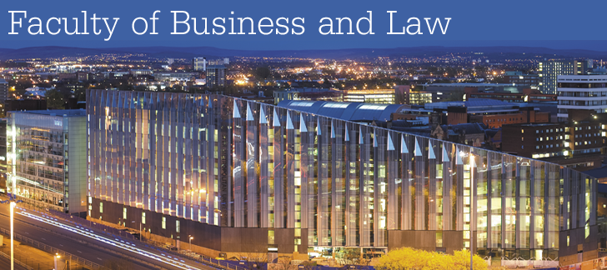

Business School

The Business School is one of the largest providers of professionally accredited courses in the UK. Set within state-of-the-art facilities our new £75m Business School provides our business partners and students with a highly professional environment within which to study and conduct their own research.

Manchester Law School

Manchester Law School has an exceptional reputation in both the professional and academic community with extensive links to the Northwest's legal profession. This is underpinned by a network of research active academics, many of whom continue to practice, producing internationally recognized research.

Информация с официального сайта MMU

